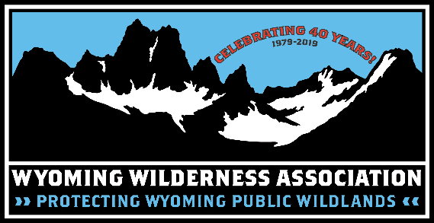

44 S. Main St. PO Box 6588 Sheridan, WY 82801 (307) 672-2751 www.wildwyo.org
Call for Artists

WWA’s 13th Annual Mini-Art Exhibit & Silent Auction:
*Celebrating Wyoming Public Lands*

Did you know the wonderful State of Wyoming is celebrating its first Public Lands Day this year on Saturday, September 28? With a few years of effort and public support, you likely were part of helping designate this day in our state. THANK YOU! To help boost the holiday, WWA has decided to pitch our annual art show to later in the year and have the Mini-Art Exhibit and Silent Auction run from mid-summer into early autumn to rein in the inaugural celebration.
As you have so kindly done in recent years, will you again donate an art piece to benefit WWA’s conservation work in Wyoming? We are pleased to announce the opportunity for regional artists to contribute miniature works of art, in support of protecting wild country in Wyoming. The talent, creativity, and generosity of our contributing artists always inspire members of the community to get out and explore with new eyes.
Art donations will be showcased and open for public bids Mon, Aug 12 thru Fri, Oct 11 on Main Street in Historic Downtown Sheridan at WWA’s headquarter office lobby. All are invited to attend the exhibit finale from 5-6:30 p.m. on October 11 to submit final bids, enjoy light fare and refreshments, and wild camaraderie with our Governing Council and statewide staff.
Please see the enclosed artist agreement form for complete details and submission specs. We thank you for your continued support to WWA.

For more information or questions, call (307) 672-2751, email heidi@wildwyo.org

